Assignment 2



Abdulrahman M Al-Mayouf ID 202002524

Instructor: Dr. Sotirios Zygiaris

BUSI 3331: Business Analytics

2 / 21 / 2024

1. 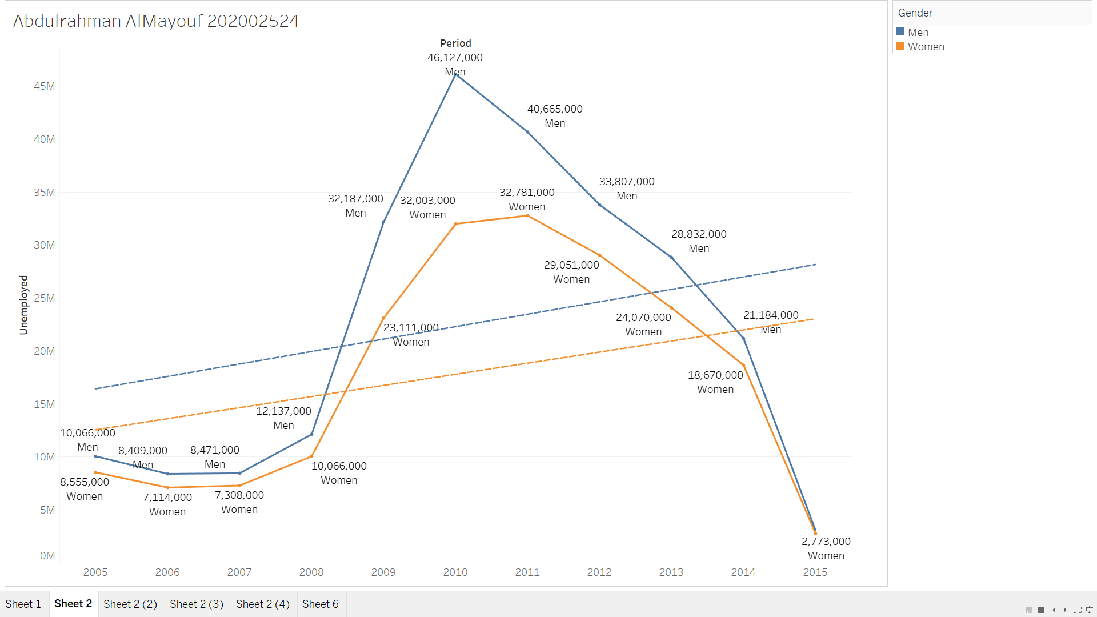Use the P1-Long term unemployment statistics.xls and create trend lines of unemployment (a) for the whole population and (b) chart for males and females.
2. 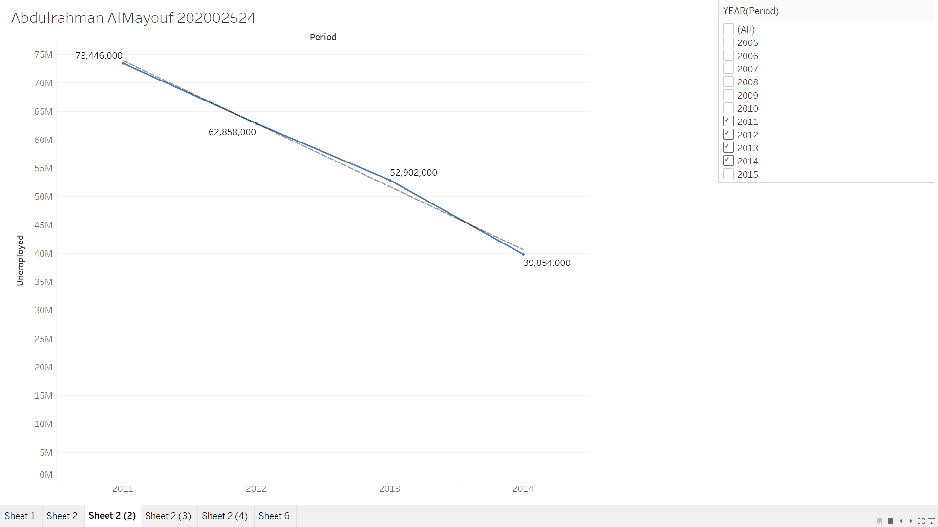Use a slope chart to show the progression of unemployment between years 2010-2014.
3. 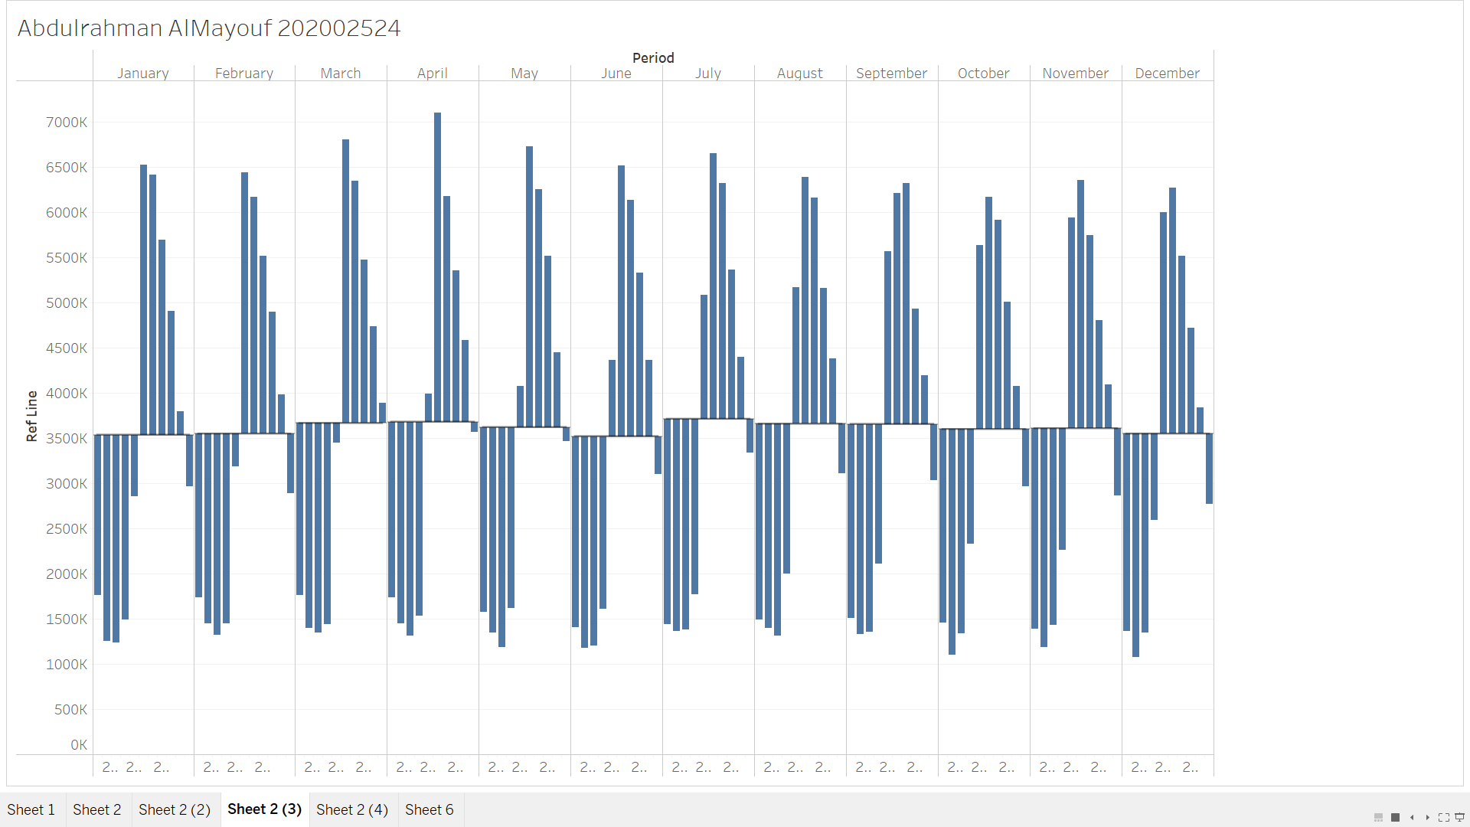Use a cycle plot chart to identify any circles of employment for the whole data set.
4. 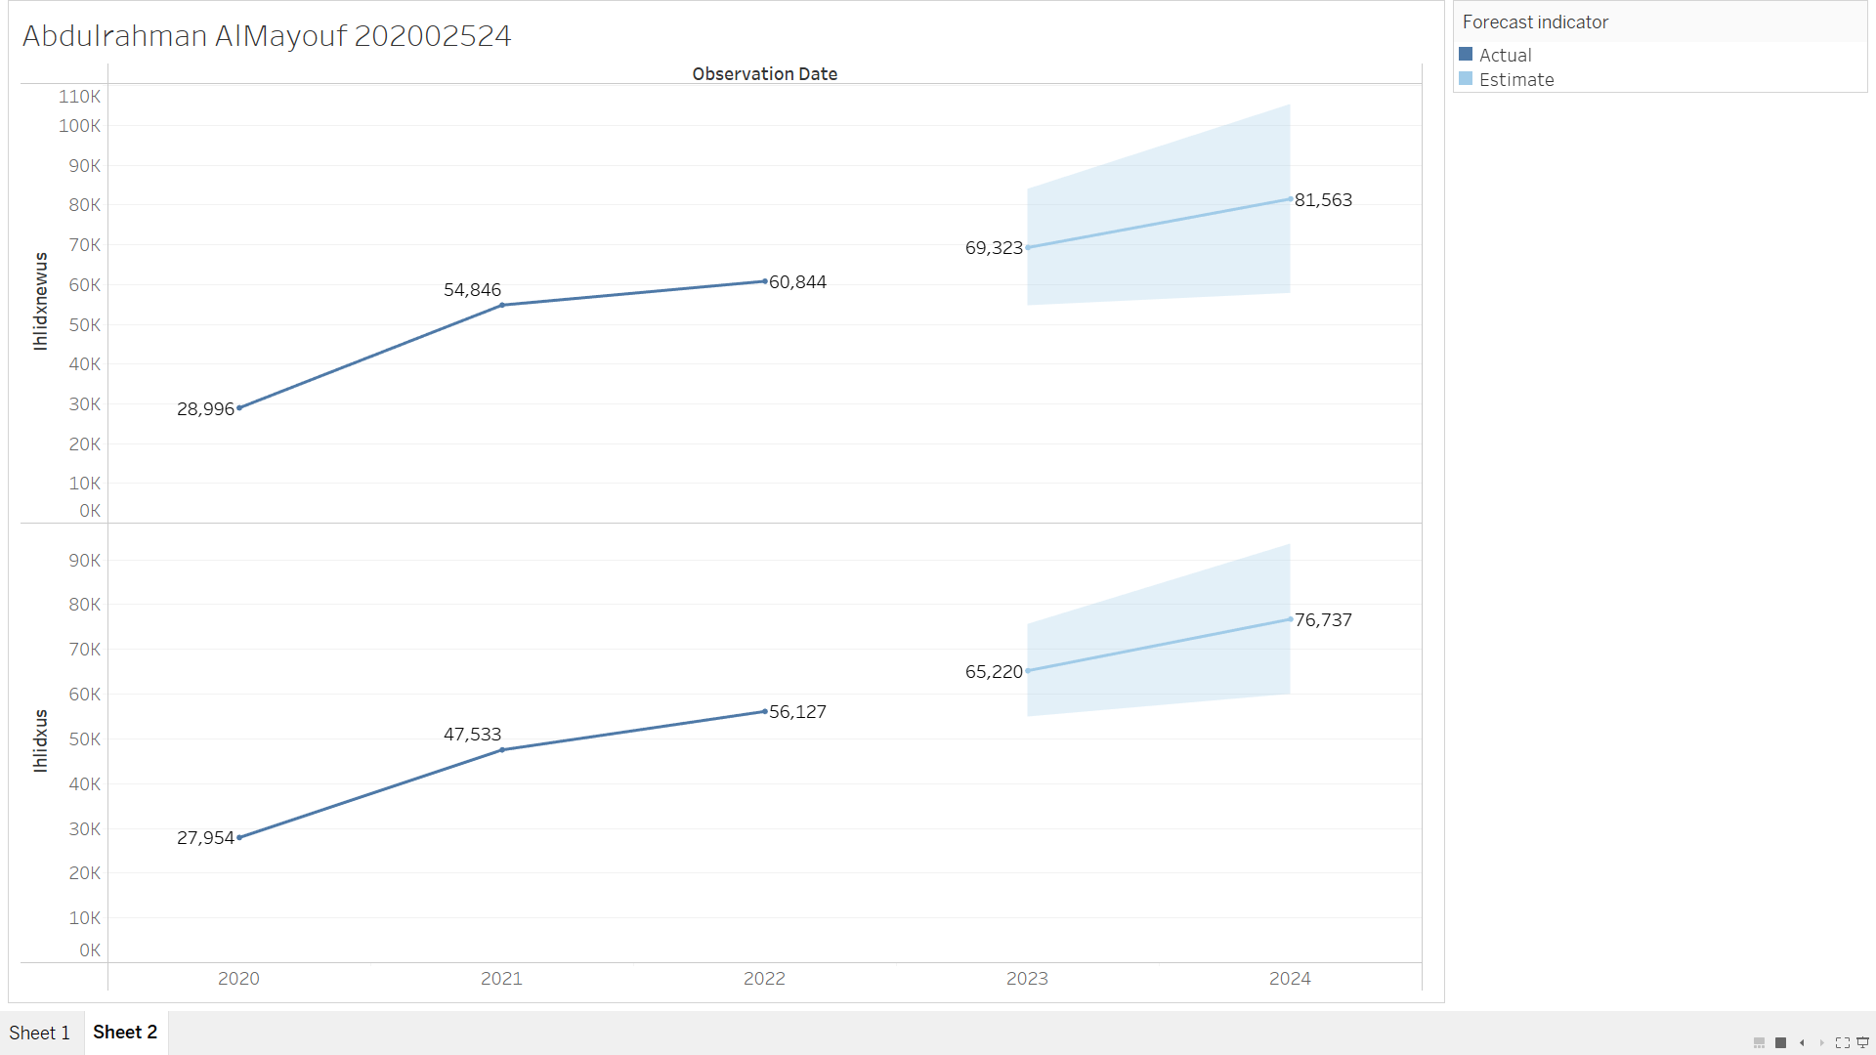Use the Fredgraph.xls create a standard forecasting on IHLIDXNEWUS. Define the period you want for your forecasting